Livestock Production Workshop Agenda
Saturday, March 21, 2020
9:30 AM – 4:00 PM MST

Time | Activity | Location | Presenter(s)
9:30 AM MST | Check In & Refreshments | Local Site
10:00 AM MST | Statewide Welcome & Recap | Live Webinar | Iris Mayes
10:10 AM MST | Overview of the Species: Pros & Cons | Live Webinar | Melissa Lines
10:40 AM MST | Rules & Regulations | Live Webinar | Colette DePhelps  Ariel Agenbroad
11:15 AM MST | BREAK and Activity #1: Mapping Your Local Resources | Local Site | Site Facilitator
11:45 AM MST | Pasture Based Livestock Systems & Fencing | Live Webinar | Rikki Ruiz
12:20 PM MST | The Small Herd Dairy Exemption in Idaho | Live Webinar | Peter Dill
12:30 PM MST | Grassfed Steers & Pastured Pigs: Feeding to Finish | Live Webinar | Melissa Lines
1:00 PM MST | LUNCH | Local Site | n/a
2:00 PM MST | Opportunities and Considerations in Poultry – Egg & Meat Enterprises | Video Recording | Janie Burns
2:50 PM MST | BREAK
3:00 PM MST | Basics of Creating Livestock Enterprise Budgets | Live Webinar | Kate Painter
3:30 PM MST | BREAK and Exercise #2: What else do WE need to know? | Local Site | Site Facilitator
4:00 PM MST | Fifteen with a Farmer Panel | Live Webinar | Melissa Lines  Peter Dill
4:30 PM MST | Wrap up, Evaluation, Action Plans | Local Site | Site Facilitator
5:00 PM MST | Adjourn

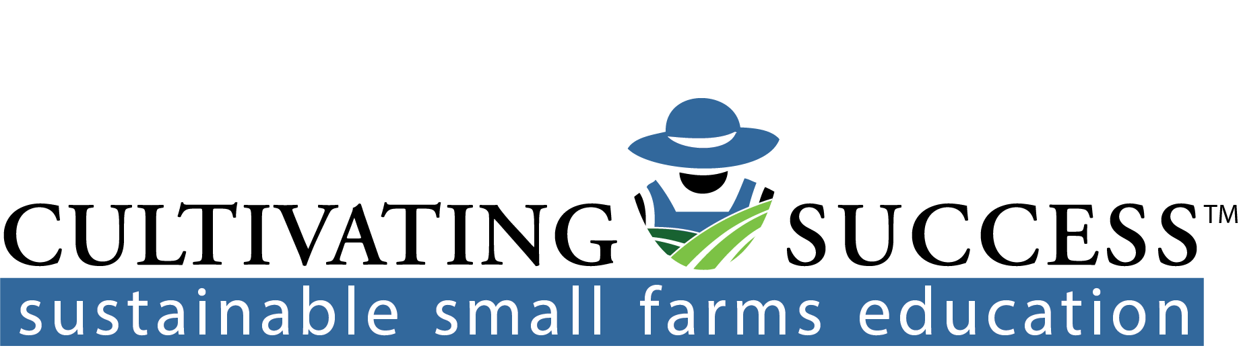
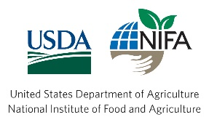
Sustainable Small Acreage Farming & Ranching is brought to you by:

