Dream Analysis.
Take an honest look at the new or existing enterprises you are considering.
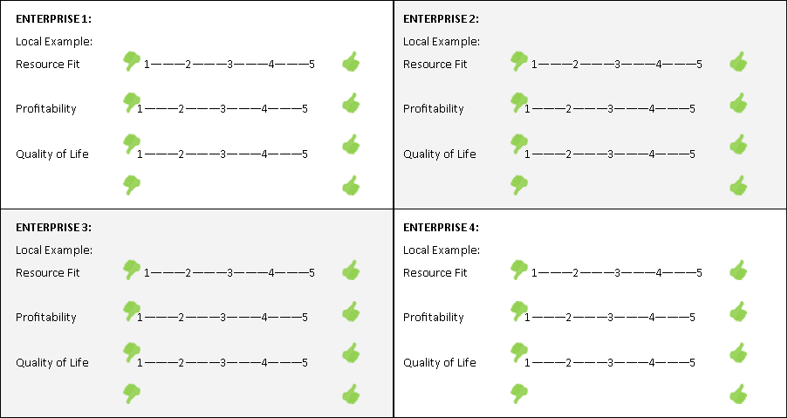
HIGHEST RANKING ENTERPRISE: 1 2 3 4

